Text/Image Feature Extraction and Recognition Using Stage based Deep Neural Networks

Lava Kumar Surparaju
School of Computing and Engineering
University of Missouri, Kansas City
lsz85@mail.umkc.edu

Abstract— An end-to-end system is proposed in this work for text spotting, extracting key features and recognizing text in natural scene environment. Our system is based on a region proposal mechanism for detection and deep CNN models for recognition. Large convolutional neural networks are used for word recognition. These models are trained using data generated by text generation engine. These models can be tested using the text based image datasets and are compared with the accuracy of the currently available text detection models. Finally, we demonstrate an application for text recognition using real world images captured.

Keywords— Unsupervised Learning, Text Recognition, Convolutional Neural Network

INTRODUCTION

Deep Learning is an emerging technology in the field of Data Science. It helps in building artificial intelligent systems with better accuracy than AI and Machine Learning. Lot of research and development is happening in this field. Feature extraction is a crucial step for Deep Learning models to find out the key features. This helps in easy learning and improves the accuracy of the model being built. Some of the Deep Learning techniques are still under development.

Text detection in natural scene environment plays a vital role in many computer vision applications. With the influence of latest multimedia recording devices, the study on the text and image data gained some importance.

RELATED WORK

In this section, we discuss the contributions that are related to our work and also the techniques studied. Traditional text detections contributions that are studied include Max Jaderberg, Karen Simonyan, Andrea Vedaldi, Andrew Zisserman “Reading Text in the Wild with Convolutional Neural Networks”[1], Xiaohang Ren, Yi Zhou, Jianhua He “A Convolutional Neural Network Based Chinese Text Detection Algorithm via Text Structure Modeling”[2], Ziwei Liu, Ping Luo, Xiaogang Wang, Xiaoou Tang “Deep Learning Face Attributes in the Wild”[3].

The stages of the proposed approach for text recognition are word bounding box proposal generation, proposal ﬁltering and adjustments, text recognition and ﬁnal merging for the speciﬁc task.

This model can later be extended to process the image data along with the text data to have a holistic understanding of a picture. This can be experimentally verified using our application which can capture the real-world picture and output the context in a few sentences by analyzing both the text and image data from the captured image using the key features.

PROPOSED WORK

The end-to-end text spotting pipeline proposed consists of the following stages.
- A combination of region proposal methods extracts many word bounding box proposal.
- Proposals are ﬁltered with a random forest classiﬁer reducing number of false-positive detections.
- A CNN is used to perform bounding box regression for reﬁning the proposals.
- A different CNN performs text recognition on each of the reﬁned proposals.
- Detections are merged based on proximity and recognition results and assigned a score.
- Thresholding the detections results in the ﬁnal text spotting result.

The proposed method for end-to-end text recognition on the image data as per the reference [1] is as shown in the comparison table below.
The proposed model is used for detecting the text from the image data, this can be later extended to detect the images in the picture using deep convolutional neural networks. Both these text and image detection of a raw picture can be segregated into two different cascade models which can work independently to extract the key features of the image and text data. All the features of the image and text data can be combined to form some meaningful conclusion what that picture represent.

This model can be used in some stand-alone mobile applications having the feature of capturing the picture using the device camera and the proposed model is used to identify the text and image data to form a meaningful conclusion and displays back to the user.

IMPLEMENTATION

The implemented model predict the real time images and the sample dataset for the model is as explained in the Fig.1. Used the Inception Model for Image dataset.
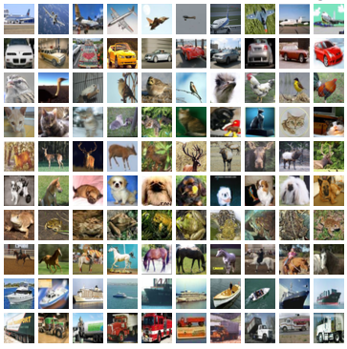
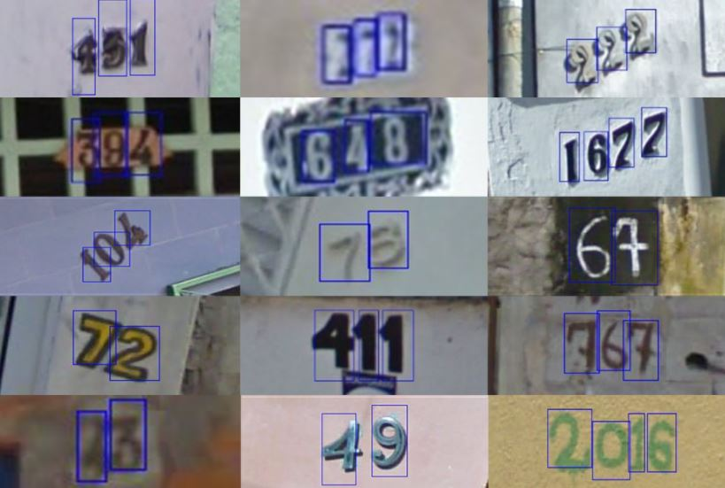

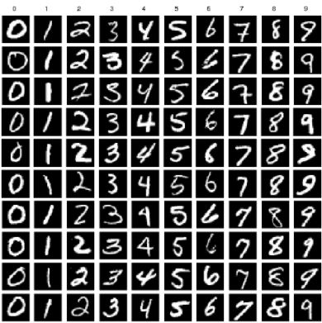
Fig.1. Dataset

The visualization of Inception model is explained in Fig.2 and the accuracy and cross entropy are predicted. The trained data results are explained in the Fig.3 and the Fig.4 represents the question answering model for the output.

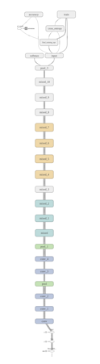
Fig 2. Inceprtion Model Visualizations
Accuracy:
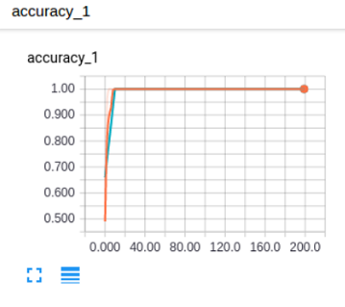
Entropy:
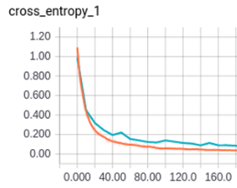

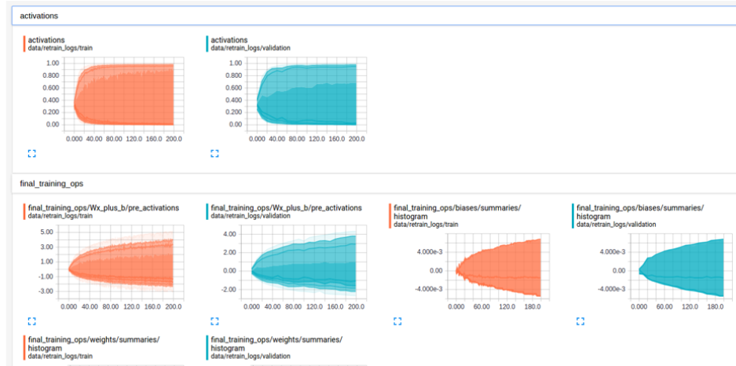
Fig 3(a). Training data Results

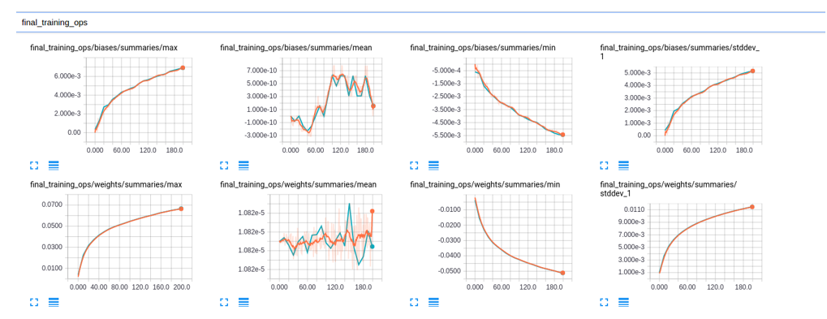
Fig 3(b). Training data Results

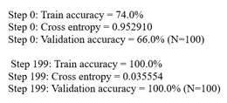
Fig 3(c). Training data Results

Results:


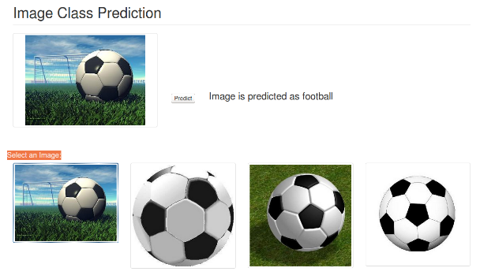
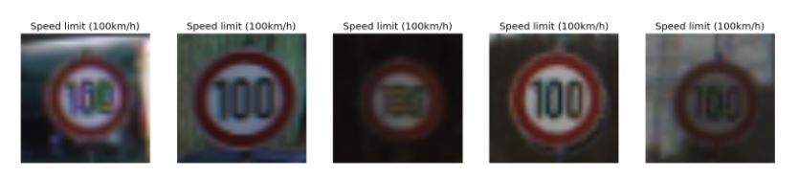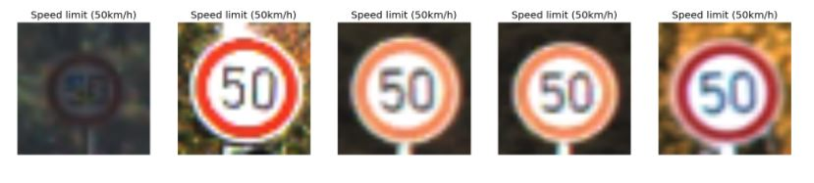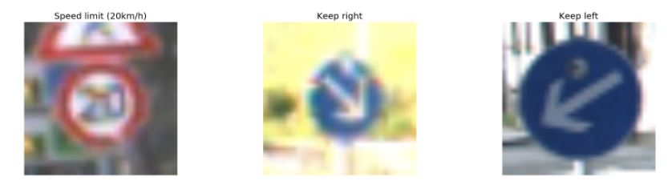

CONCLUSION

The proposed Inception Model helped obtained better results for the image data. The results are better when compared with other image recognition systems. This system application for text and image data recognition will help in understanding a real-world image data.

ACKNOWLEDGMENT

This work was done in partial fulfillment of the requirements of CS5597: Directed Readings and CS5542: Big Data Analytics and Apps, CSEE Department, University of Missouri – Kansas City (Spring 2017). Instructors: Dr. Yugyung Lee, Chandra Shekar, Mayanka, TAs: Maddula, Manikanta, Peddinti, Sudhakar Reddy, Vadlamudi, Naga K.

REFERENCES

- Max Jaderberg, Karen Simonyan, Andrea Vedaldi, Andrew Zisserman “Reading Text in the Wild with Convolutional Neural Networks”.

- Xiaohang Ren, Yi Zhou, Jianhua He “A Convolutional Neural Network Based Chinese Text Detection Algorithm via Text Structure Modeling”.

- Ziwei Liu, Ping Luo, Xiaogang Wang, Xiaoou Tang “Deep Learning Face Attributes in the Wild”.

- Almazán,J.,Gordo,A.,Fornés,A.,&Valveny,E.(2014).Wordspotting and recognition with embedded attributes. IEEE Transactions on Pattern Analysis and Machine Intelligence, 36(12), 2552–2566.

- Alsharif, O., & Pineau, J. (2014). End-to-end text recognition with hybrid HMM maxout models. In International conference on learning representations.

- S. M. Lucas, “Icdar 2005 text locating competition results,” in Document Analysis and Recognition, 2005. Proceedings. Eighth International Conference on. IEEE, 2005, pp. 80–84.

- Samina Khalid, Tehmina Khalil, Shamila Nasreen ; “A Survey of Feature Selection and Feature Extraction Techniques in Machine Learning”.

- L. Ladla and T. Deepa, “ Feature Selection Methods And Algorithms”, International Journal on Computer Science and Engineering (IJCSE), vol.3(5), pp. 1787-1797, 2011.

- H. Motoda and H. Liu, “Feature selection, extraction and construction” In: Towards the Foundation of Data Mining Workshop, Sixth PacificAsia Conference on Knowledge Discovery and Data Mining (PAKDD 2002), Taipei, Taiwan, pp. 67–72, 2002.

[10] Li Deng and Dong Yu (2014), "Deep Learning: Methods and Applications", Foundations and Trends® in Signal Processing: Vol. 7: No. 3–4,pp197-387.

